Association des Compagnons Bâtisseurs asbl
Volunteering project : BELGIUM/ 12 MONTHS

The hosting Organisation:
The “Association des Compagnons Bâtisseurs”, aka CBB, is a non-profit, non-political Youth Organisation recognised by the Wallonia-Brussels Federation of Belgium. The organisation proposes different kinds of activities, mainly based on volunteering and non-formal education: local and international work-camps, youth exchanges, medium and long term voluntary services, leisure time activities for and with disabled people.

All these activities would not be possible without a network of 327 members, 250 international volunteers during the summer and a team of 11 employees.

As we are a Youth Organisation, most of our public is aged between 16 and 25 years, even if there is not upper age limit to integrate our groups of volunteers. Within our members, one person out of ten has a mental disability.

We have participated in the EVS Program both as sending and hosting organisation since 1997. We were accredited as coordinating organisation in 2007.

We believe that the EVS program perfectly fits with our goals and methods: non-formal education, citizen awareness, volunteering, and multiculturalism are keywords in our daily action. We also particularly appreciate the learning opportunities that the EVS offers to all young people, regardless to their origins, background and economical means.

CBB is also member of the ALLIANCE of European Voluntary Service Organisations.

Location of the project:
Compagnons Bâtisseurs asbl presents the specificity to develop of lot of international exchanges and to be located in a small town of the south-French-speaking part of Belgium. From our office, based in the main square of Marche-en-Famenne, a 17 000 inhabitants town of the province of Luxembourg, we organise projects all over the Wallonia-Brussels Federation of Belgium and we maintain close partnerships with non-profit organisations from all over the world. This unique situation will allow the volunteer to share the semi-rural life style of the area, but also to meet young people from different places of the country as well as to be in contact with people from the other side of the earth.

During his/her EVS, the volunteer will live in Marche-en-Famenne. The town offers all modern facilities (shops, supermarkets, sport centre, cinema….).

!!!IMPORTANT!!! : Our town is located in a semi-rural area. For the urban life-style-lovers it is important to know that even if it is not far away from the biggest Belgian cities (60 km from Liège, 100 km from Brussels, 50 km from Namur) and well connected by train, Marche-en-Famenne can sometimes look very quiet.

In Marche-en-Famenne the volunteer will live at “CBB Volunteers’ house”, a comfortable house near to the town centre.
S/he will have his/her own room and will share the common spaces with other 5 EVS volunteers involved in other EVS projects in Marche-en-Famenne.

The project:
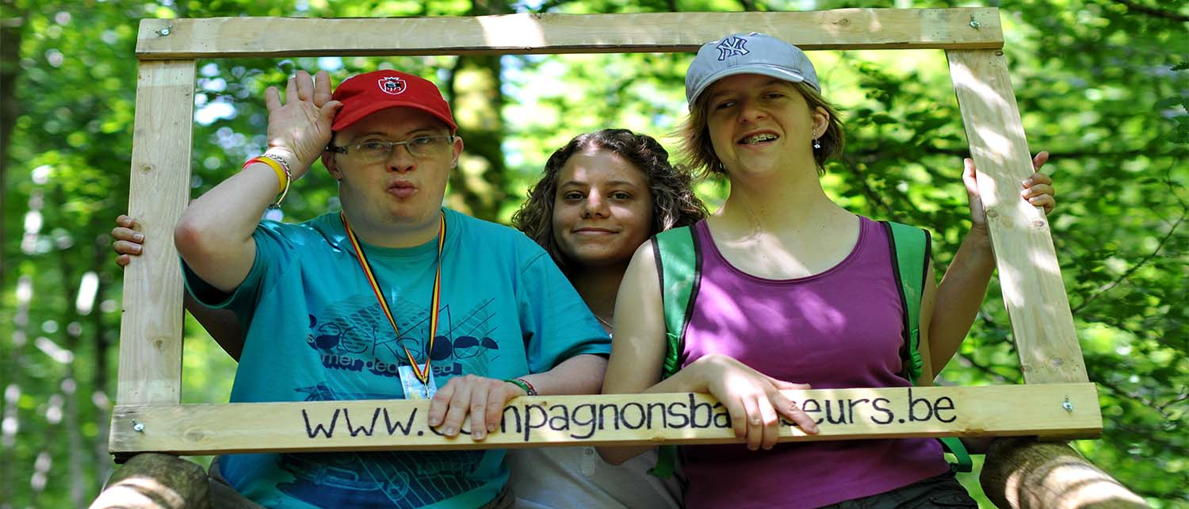

As said before, CBB develop different kinds of actions mainly focused on group dynamics. Through these actions the association also tries to promote inclusion of people with fewer opportunities and people with learning difficulties or disabilities.
Our EVS volunteer will be actively involved in our activities, from the preparation to the evaluation, and her/his role will mainly be to facilitate, together with CBB leaders and other CBB volunteers, the participation of people with fewer opportunities or disabilities.

The volunteer will be particularly involved in three CBB actions:
- The programme “Volunteering, leisure time and disability”;
- Organization and animation of projects as work camps and youth exchanges whose aim is the integration of youngsters with less opportunities;
- CBB training for young leaders of summer camps.

1-The programme “Volunteering, leisure time and disability developed by CBB organisation aims to develop among young people a better awareness about disability as well as to favour the participation of people in situation of mental disability in CBB projects.
Together with the staff members, the EVS volunteer will be in charge of the preparation, animation and evaluation of residential week-ends, summer camps and evening activities for groups of people with mental disability. The tasks will be varied and can be organised according to the skills, interests and abilities of the young volunteer.
Here below is an example of tasks concerning the organization of a week-end of activity:
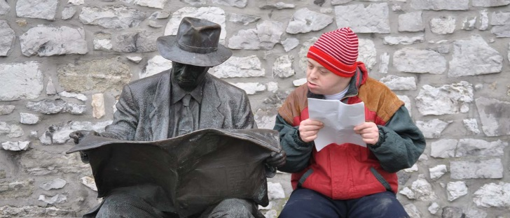
Before the week-end: to search for an accommodation, to organise the logistics, to plan the menus, to plan cultural and sports activities as well as touristic visits…
During the week-end: to welcome the group of participants, to provide an individual support to the people with disability (this may include sanitary support to the persons), to facilitate the group dynamic, to lead a cultural visit, a group game…
After the week-end : to evaluate the activity with the others leaders, to write articles and to post news on the organisation’s Facebook public page about the week-end, to prepare a small report addressed to the parents of the participants with disability…
Each year, CBB organises around 20 residential week-ends of such type. We also organise 2 camps of 10 days in Belgium and 2 camps abroad. Around 20 persons participate in each of these projects; more than half of them are in situation of mental disability (mostly learning difficulties and Down syndrome).
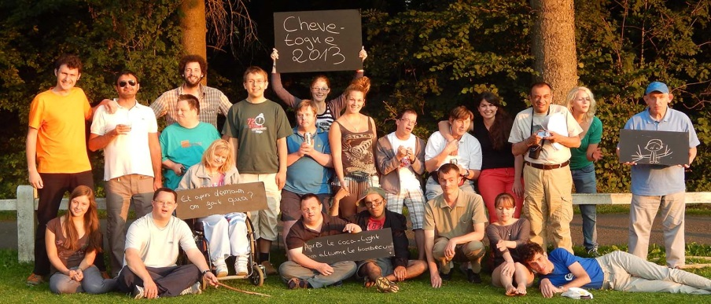
Every two months Friday evening cine-club and monthly table games evenings are also usual activities developed within the programme “Volunteering, leisure time and disability”.

2- Our EVS volunteer will also take part in other projects as work camps and youth exchanges whose aim is the integration of youngsters with less opportunities.

3- S/he will be part of CBB animators’ team who will organize a training cycle for summer camps leaders.
With CBB staff members the volunteer will be in charge of the good implementation of the training and s/he will have the opportunity of taking initiatives, organizing workshops and bringing new ideas. Being involved in this training will enable our volunteer to be sensitized to the topic of group management, techniques of animation, organization of activities.

- In this EVS project, we really wish the volunteer to develop a personal initiative so any idea and proposal of new activity is welcome!

Profile of the volunteer:
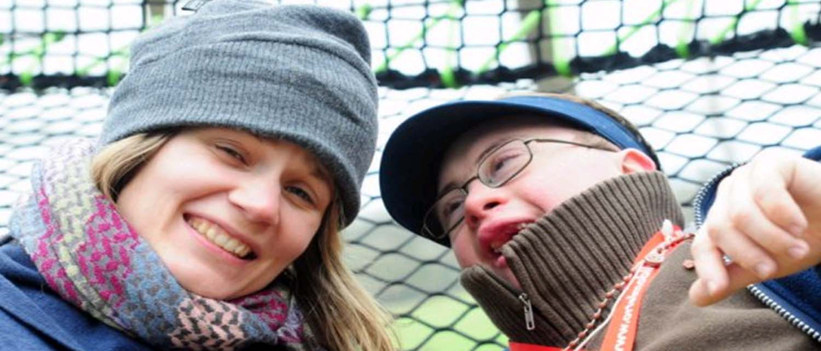

For this project, CBB requests from the volunteer:
- To be able to communicate in French at a reasonable level as s/he will share a lot of time with people with mental disability who do not know any other language;
- To be highly motivated to work for a better social participation and inclusion of people with disability and fewer opportunities;
- To enjoy the group life and to be ready to participate in several residential week-ends and camps in company of lots of people;
- Not to be discouraged by office and computer work, as several tasks in this project also concern the preparation and the evaluation of the activities which are done at the office.

Project period: EVS activity will start on 01/10/2018 for a duration of 12 months

Volunteer hosted on this project: 1

Application deadline: 06th August 2018 12h00

Contacts:

Sending organization:
Name
Organisation
Address
E-mail
Telephone

Hosting organization:
Name | Morgane Hazard
Organisation | Association des Compagnons Bâtisseurs asbl
Address | 9 Place du Roi Albert, Marche-en-Famenne, 6900, Belgique
E-mail | evs@compagnonsbatisseurs.be | web | www.compagnonsbatisseurs.be
Telephone | +32 84 31 44 13

